

CSE302 (Section 1)
[Summer 2022]

Lab Assignment Submission Report

Assignment Title: Lab tasks of LAB01

Submitted by:
Aisha Siddika Mim
2020-1-60-040

1. Screenshots

LAB TASK 01 (a):

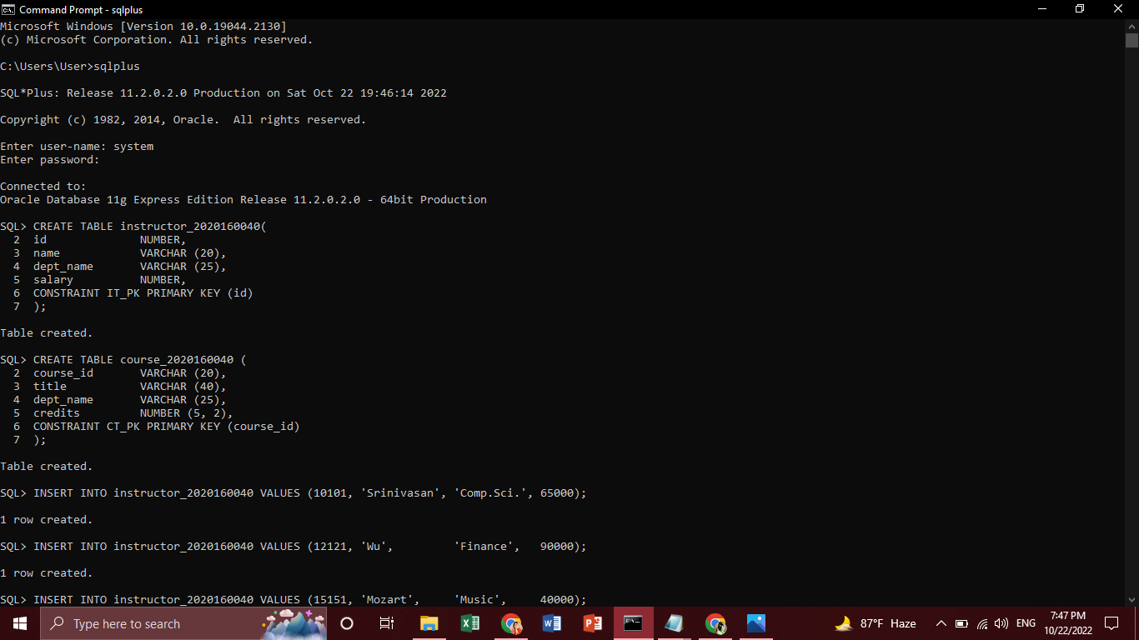

LAB TASK 01 (b):

LAB TASK 02 (a):

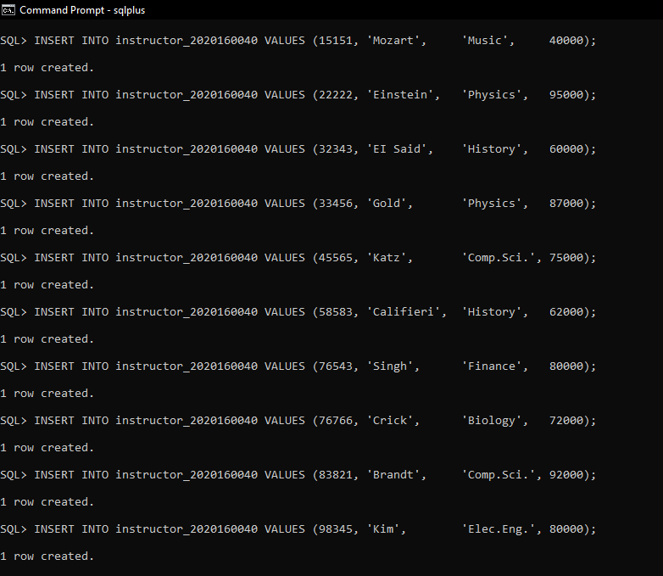

LAB TASK 02 (b):

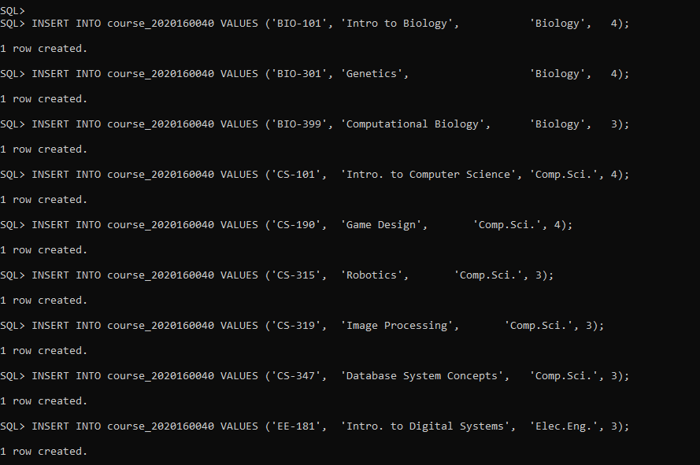

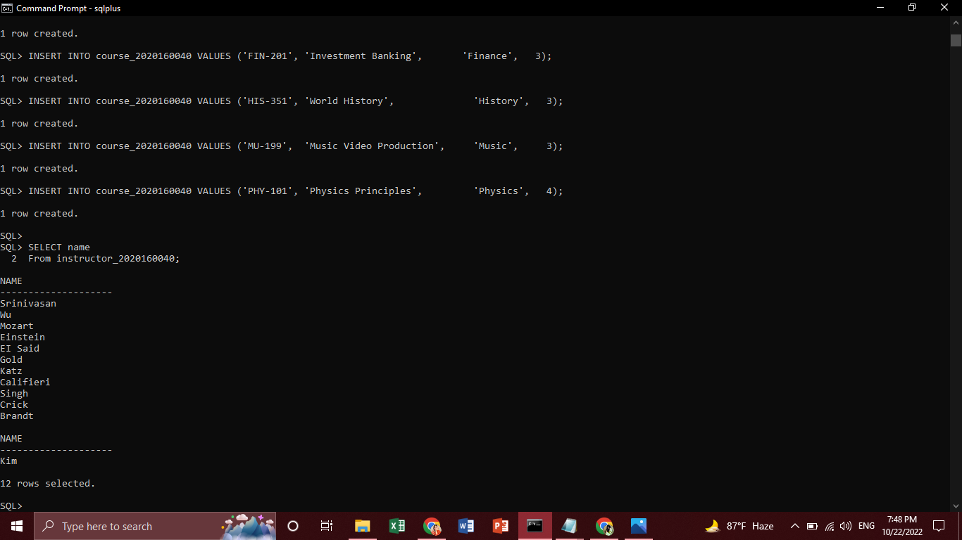

LAB TASK 03 (i):

LAB TASK 03 (ii):

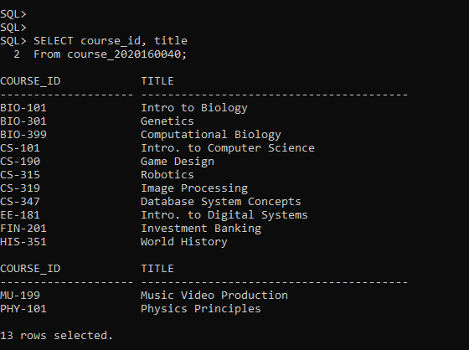
LAB TASK 03 (iii):

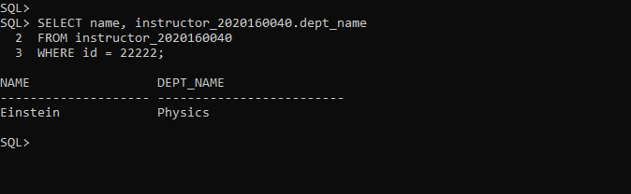

LAB TASK 03 (iv):

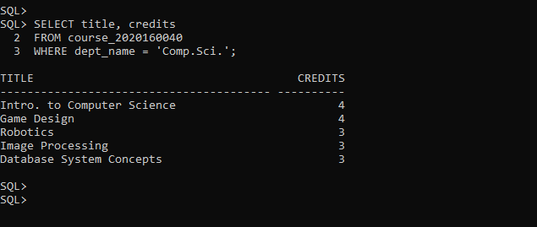

LAB TASK 03 (v):

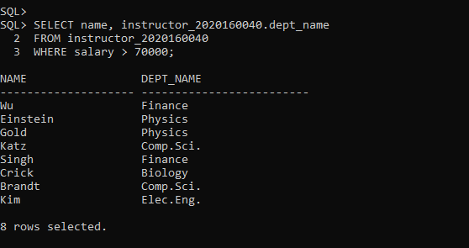
LAB TASK 03 (vi):

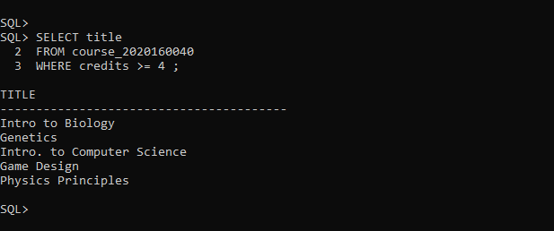

LAB TASK 03 (vii):

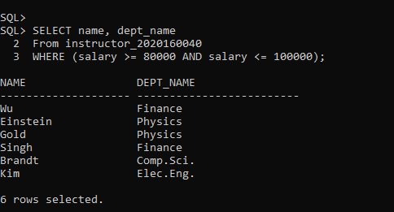

LAB TASK 03 (viii):

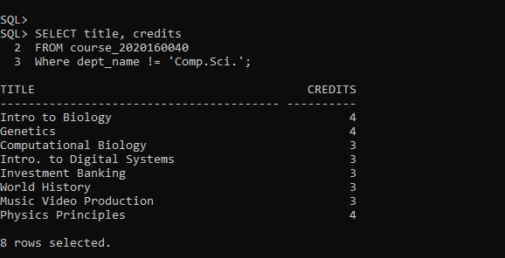

LAB TASK 03 (ix):

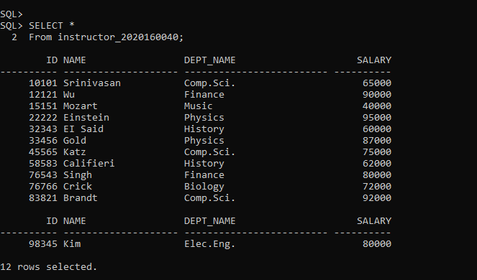

LAB TASK 03 (x):

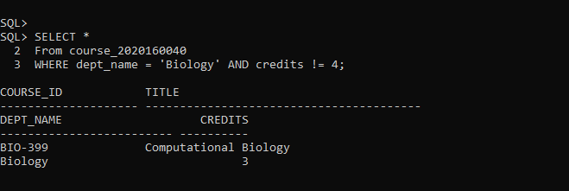

2. Learning Outcomes

Previously, I learned how to create tables, insert, and update and delete information. From this lab, firstly, I learned how to run sqlplus in command prompt. I also learned the process of identifying and declaring primary and foreign keys. If I want to see any information from any table based on s requirements or conditions, I have learned and practised how to show the information of that table. And, the concepts of creating table, inserting, updating and finding information from tables has been clearer by doing this lab.

